***Bonjour mes amis!***

***Mon passeport français 5e à la 6e année***

While we are apart, complete as many of the French activities that

you can on - Mon passeport. Check off those you accomplish.

When we are all together again, you can share your passport,

posters, collage or recording with your friends and teacher.

The shaded boxes are a bit more challenging, but give them a try.😊

All riddles retrieved from <http://www.radio-canada.ca/jeunesse/passions/livres/jeux/rebus/index.shtml?sect=jeux> (2010)

|  |  |  |
| --- | --- | --- |
| Listen to music *en français*  Radio  91.1 FM (envol91.mb.ca) | Can you solve this riddle? | Make a word splash of as many food words *en français* as you know.  How many are there?  Bravo! |
| Read the ingredients *en français* on a box of cereal or other food.  How many words do you recognize? | Make a poster or a Venn diagram that depicts your culture and Francophone cultures: celebrities, food, holidays, street names, music, names of communities, traditions, etc.  What similarities do you see between your culture and Francophone cultures? | Read a simple book or poem *en français* to a younger sibling or to a parent.  Did you recognize les *mots-amis*? |
| Make a collage of yourself and use it to orally describe yourself *en français*, giving as many details about yourself as possible. | Keep a simple journal *en français*. In this journal, you can record the date, the weather, and write one or two sentences on your own *en français* (emotions, activities you’re doing on that day, etc.) | Make a crossword of French words: think of weather words, food words, clothing, sports, pastimes, animals, calendar words. |
| Record yourself speaking *en français* about your likes and dislikes using J’aime … and Je n’aime pas … (food, sports, clothing, pastimes, seasons, weather, etc.) and share it with a sibling, a friend, a parent or your teacher upon your return to school. | Can you solve this riddle? | Play a game of Scrabble *en français* with a sibling. Just make words that you know and try to use them in a complete sentence. For example: froid / Il fait froid.  You can find a Scrabble board on the back of this sheet. |
| Can you solve this riddle?  **A**, **B**, **C**, **D** et **E** aiment participer aux sports. **A** aime le baseball ou le hockey.  **B** aime le basketball ou le soccer. Le sport préféré de **C** n’est pas le soccer ni le basketball. **D** participe à un sport d’hiver. Finalement, **E** participe au sport dans le gymnase avec un ballon et 2 paniers.  Quelle personne aime  :  le baseball?  le basketball?  le soccer?  le tennis?  le hockey? | Watch a movie or a TV show in French  (select language on DVD)  Try watching a Disney movie or another movie that you have already have and watch it in French. Do you recognize important words and names? | Can you solve this riddle?  **A**, **B**, **C**, **D** et **E** aiment s’amuser. Dans son temps libre, **A** aime faire de la cuisine avec sa famille. **B** aime faire un passe-temps seul. **C** est très rythmique et **D** adore être dehors.  Quelle personne aime  :  jouer du piano?  faire de la cuisine?  faire de la planche à neige?  danser?  lire? |

|  |  |  |  |  |  |  |  |  |  |  |  |  |  |  |  |  |
| --- | --- | --- | --- | --- | --- | --- | --- | --- | --- | --- | --- | --- | --- | --- | --- | --- |
|  |  |  | **4** |  |  |  |  | **5** |  |  |  |  | **4** |  |  |  |
| **5** |  |  |  |  |  |  |  |  |  |  |  |  |  |  |  | **5** |
|  | **5** |  |  |  |  |  |  |  |  |  |  |  |  |  | **5** |  |
|  |  | **4** |  |  |  | **3** |  |  |  | **3** |  |  |  | **4** |  |  |
|  |  |  | **4** |  |  |  |  |  |  |  |  |  | **4** |  |  |  |
|  |  |  |  | **4** |  |  |  | **5** |  |  |  | **4** |  |  |  |  |
|  |  |  |  |  | **4** |  |  |  |  |  | **4** |  |  |  |  |  |
|  |  |  |  |  |  | **3** |  |  |  | **3** |  |  |  |  |  |  |
|  |  |  |  |  |  |  | **2** |  | **2** |  |  |  |  |  |  |  |
| **6** |  | **4** |  | 2 |  |  |  | **\*** |  |  |  | **2** |  | **4** |  | **6** |
|  |  |  |  |  |  |  | **2** |  | **2** |  |  |  |  |  |  |  |
|  |  |  |  |  |  | **3** |  |  |  | **3** |  |  |  |  |  |  |
|  |  |  |  |  | **4** |  |  |  |  |  | **4** |  |  |  |  |  |
|  |  |  |  | **4** |  |  |  | **5** |  |  |  | **4** |  |  |  |  |
|  |  |  | **4** |  |  |  |  |  |  |  |  |  | **4** |  |  |  |
|  |  | **4** |  |  |  | **3** |  |  |  | **3** |  |  |  | **4** |  |  |
|  | **5** |  |  |  |  |  |  |  |  |  |  |  |  |  | **5** |  |
| **5** |  |  |  |  |  |  |  |  |  |  |  |  |  |  |  | **5** |
|  |  |  | **4** |  |  |  |  | **5** |  |  |  |  | **4** |  |  |  |

Jouons Scrabble!

You can keep score or not while playing Scrabble.

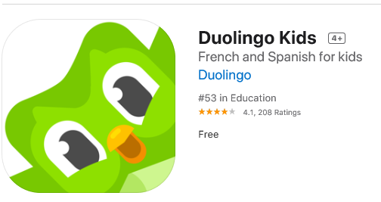Here is a list of websites to try out! Have fun.

1. Duo Lingo for kids, (a free app)

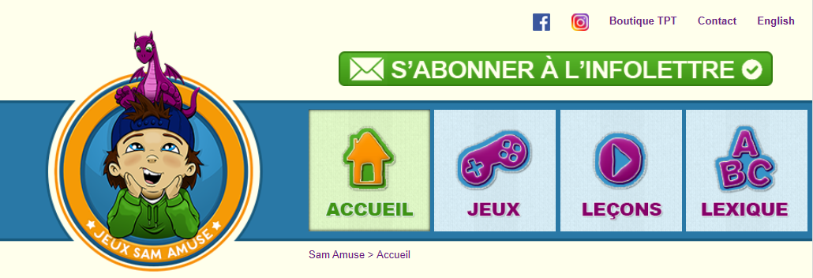2. <https://www.samamuse.ca/>

3. <https://www.digitaldialects.com/French.htm>

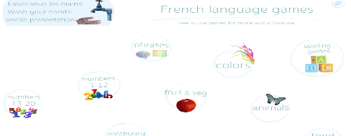

4. <http://www.hello-world.com/languages.php/?language=French/>

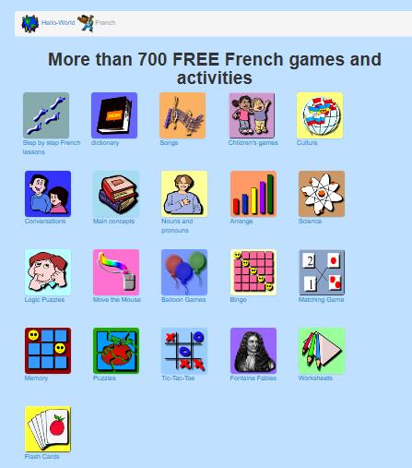

5. <https://ici.radio-canada.ca/jeunesse>

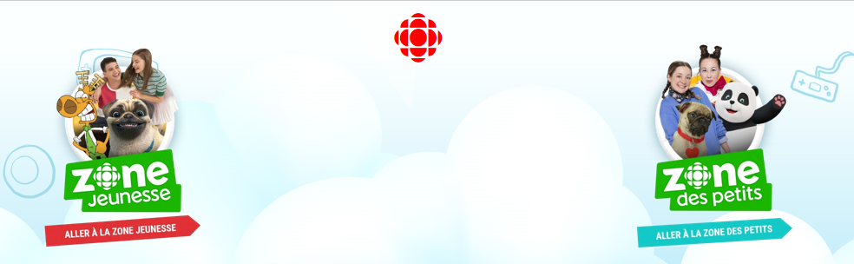

6. <http://fslactivities.ca/frquiz.html>

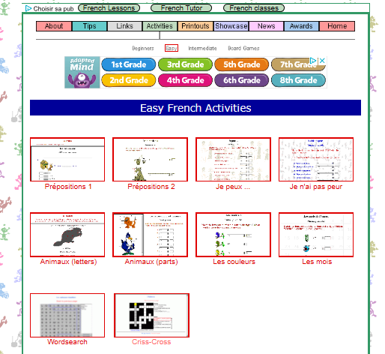

7. <https://www.quia.com/shared/french/>

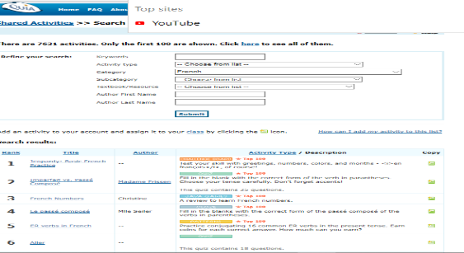

8. Greetings (l’accueil)

<https://www.youtube.com/watch?v=nhEHGcWa1dk>

<https://www.youtube.com/watch?v=KZk64LAyqrY&list=RDKZk64LAyqrY&start_radio=1#t=1>

<https://www.youtube.com/watch?v=9BgyvEXTZbk>

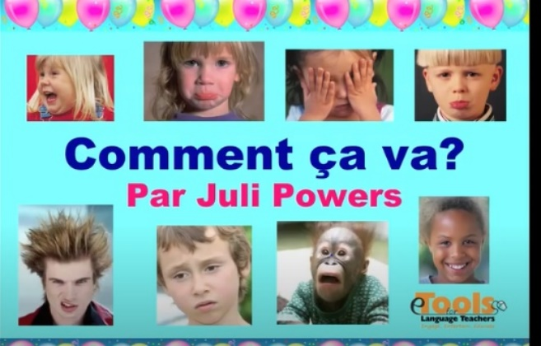

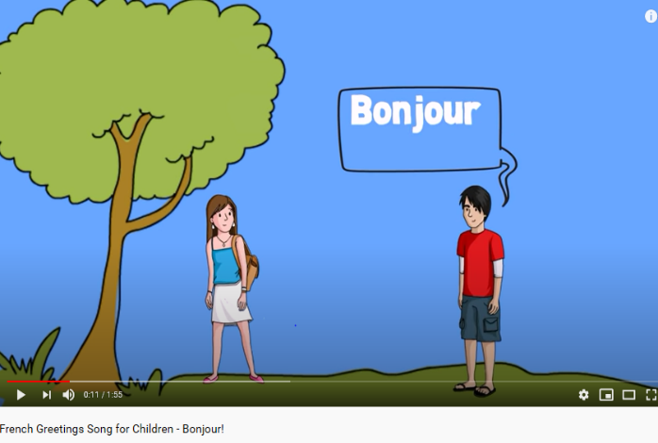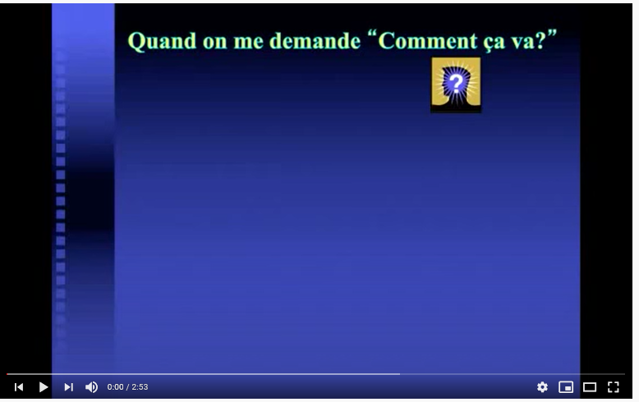

9. Numbers (les numéros)

<https://www.youtube.com/watch?v=FSESUz5PV_0>

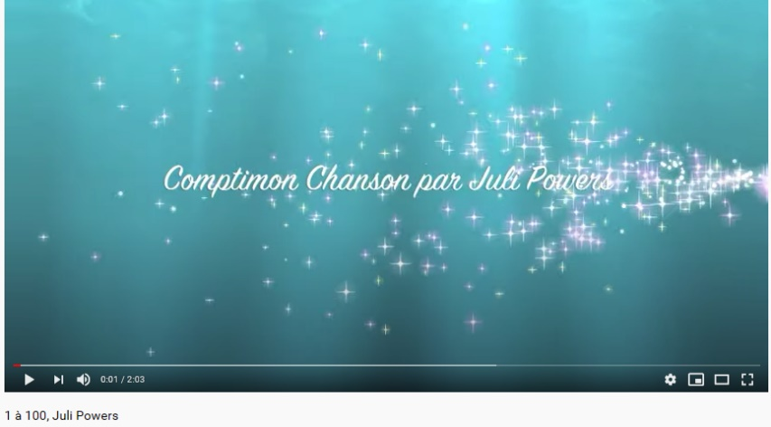

10. Téléfrançais has many episodes!

<https://www.youtube.com/watch?v=rBSflK1FTSY>

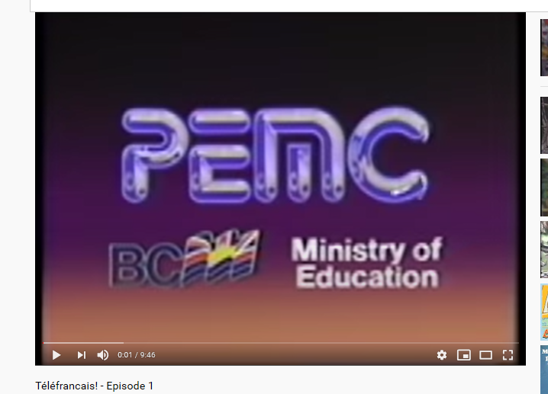

11. Family (la famille)

<https://www.youtube.com/watch?v=Nuo6ORn_Wdw>

<https://www.youtube.com/watch?v=MFk9YmJv-jc>

<https://www.youtube.com/watch?v=IfLnFGLW588>

<https://www.youtube.com/watch?v=wXcFBr5kWqQ>

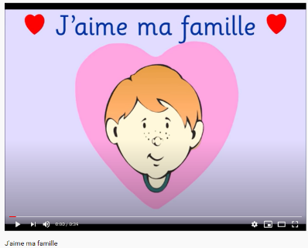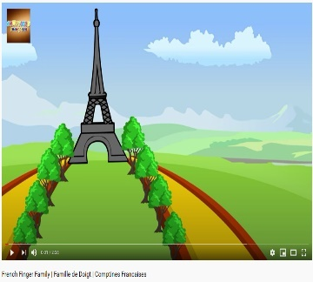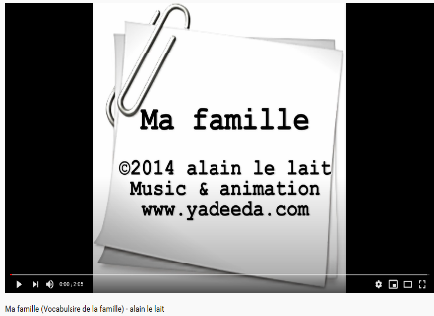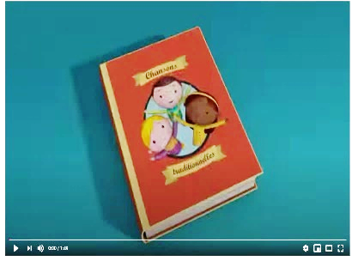

12. Adjectives and Calendar (les adjectifs et le calendrier)

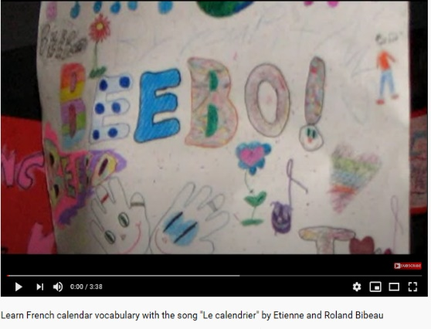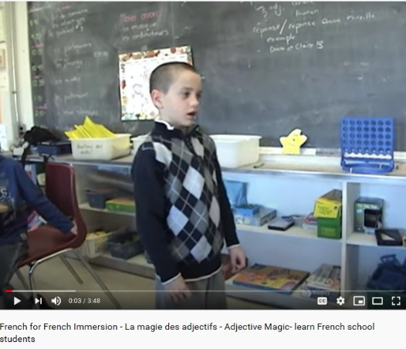<https://www.youtube.com/watch?v=rjejV75FLmY>

<https://www.youtube.com/watch?v=4AHS2AMwbpg>